**Lesson 4 Demo 4**

**Understand the Working of Pod Allocation**



Steps to be followed:

1. Adding node selector to the pod configuration

**Step 1: Adding node selector to the pod configuration**

1. Navigate to the deployments folder:

***cd deployments***

1. Open the pod yaml file:

***vi singlepod.yaml***



1. Add **nodeSelector** to the pod configuration by adding the following lines under **spec** section at the end of **singlepod.yaml** file:

***nodeSelector:***

***disktype: ssd***

| **Note:** Press the **esc** button and type **:wq** to save and exit the file. |
| --- |

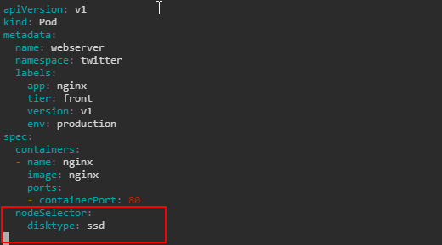

1. Enter the following command to configure the changes in singlepod.yaml:

***kubectl apply -f singlepod.yaml***



